**WEB APPLICATION USING NODE RED**

|  |  |
| --- | --- |
| Date | 08 November 2022 |
| Team ID | PNT2022TMID19760 |
| Project Name | SmartFarmer – IoT ENABLED SMART FARMING APPLICATION |

**FLOW 1:**

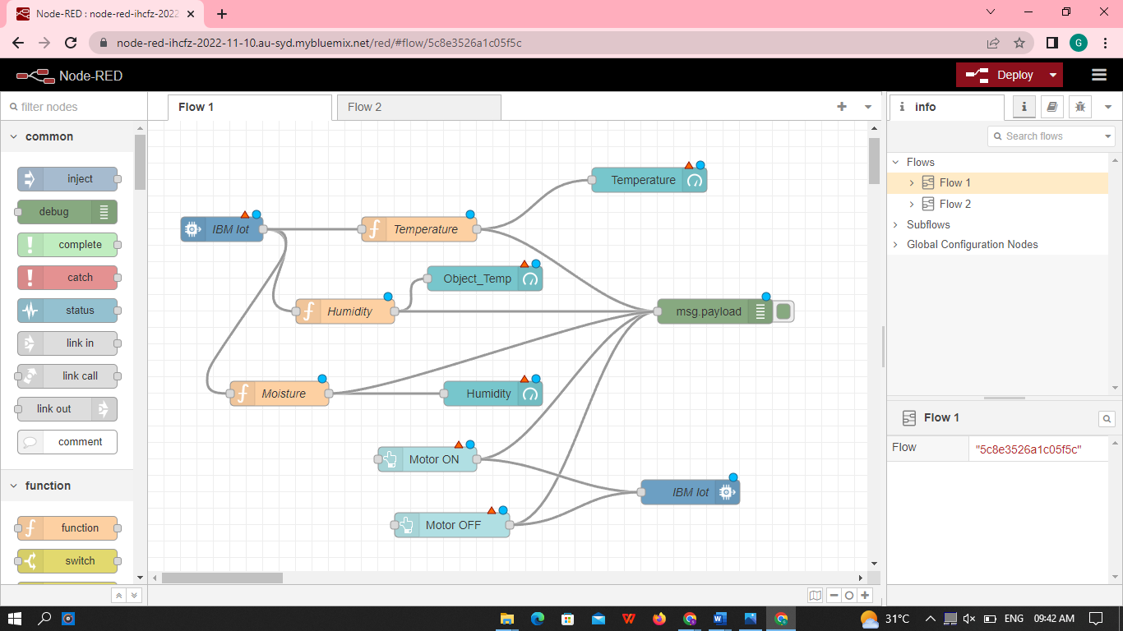

**FLOW 2:**

